**NETWORK SIMULATOR 2(NS-2)**

Reg no:185001161

**PERFORMANCE EVALUATION OF TCP AND UDP**

Write ns2 programto do Performance Evaluation of TCP and UDPsharing a bottleneck link.

**Script File:**

set ns [new Simulator]

$ns color 1 blue

$ns color 2 red

set n0 [$ns node]

set n1 [$ns node]

set n2 [$ns node]

set n3 [$ns node]

set n4 [$ns node]

set n5 [$ns node]

set f [open out.tr w]

$ns trace-all $f

set nf [open out.nam w]

$ns namtrace-all $nf

$ns duplex-link $n0 $n2 2Mb 10ms DropTail

$ns duplex-link $n1 $n2 2Mb 10ms DropTail

$ns simplex-link $n2 $n3 0.3Mb 100ms DropTail

$ns simplex-link $n3 $n2 0.3Mb 100ms DropTail

$ns duplex-link $n3 $n4 0.5Mb 40ms DropTail

$ns duplex-link $n3 $n5 0.5Mb 40ms DropTail

$ns duplex-link-op $n0 $n2 orient right-up

$ns duplex-link-op $n1 $n2 orient right-down

$ns simplex-link-op $n2 $n3 orient right

$ns simplex-link-op $n3 $n2 orient left

$ns duplex-link-op $n3 $n4 orient right-up

$ns duplex-link-op $n3 $n5 orient right-down

$ns queue-limit $n2 $n3 10

$ns simplex-link-op $n2 $n3 queuePos 0.5

$ns simplex-link-op $n3 $n2 queuePos 0.5

set tcp [new Agent/TCP/Newreno]

$ns attach-agent $n0 $tcp

set sink [new Agent/TCPSink/DelAck]

$ns attach-agent $n4 $sink

$ns connect $tcp $sink

$tcp set fid_ 1

$tcp set window_ 8000

$tcp set packetSize_ 512

set ftp [new Application/FTP]

$ftp attach-agent $tcp

set udp [new Agent/UDP]

$ns attach-agent $n1 $udp

set null [new Agent/Null]

$ns attach-agent $n5 $null

$ns connect $udp $null

$udp set fid_ 2

set cbr [new Application/Traffic/CBR]

$cbr attach-agent $udp

$cbr set type_ CBR

$cbr set packetSize_ 1024

$cbr set rate_ 0.01mb

$cbr set random_ false

$ns at 0.1 "$cbr start"

$ns at 1.0 "$ftp start"

$ns at 4.5 "$ftp stop"

$ns at 5.0 "$cbr stop"

$ns at 6.0 "finish"

proc finish {} {

global ns f nf

$ns flush-trace

close $f

close $nf

puts "running nam..."

exec nam out.nam &

exit 0

}

$ns run

**Inference:**

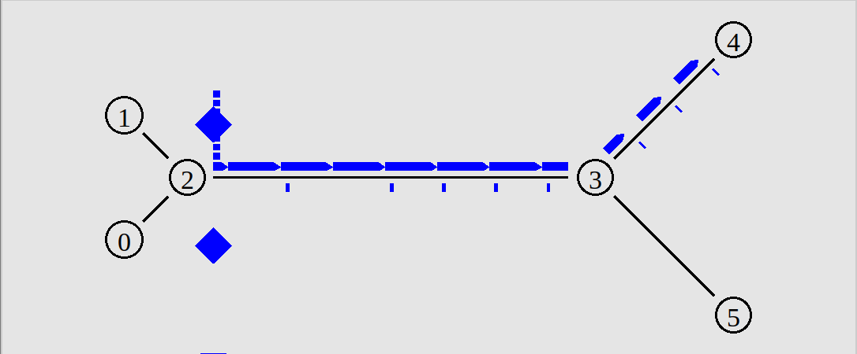

* The TCP Connection between n0 to n4 has the packet drop.
* The bandwidth between the link n2 to n3 is very low and high delay,hence it becomes a
* bottleneck link .
* Because the small queue size of the bottleneck link between n2 and n3 it couldn’t accomodate all the packets within the link from node 0 ,the packet drop has happend.
* Reason for the delay in the network is size of the queue maybe small,

huge accumulation at the end,insufficient bandwidth allocated to the

shared link(bottleneck).

* By addressing the above issues, such as increasing the bandwidth ,increasing the queue size and reducing the delay.